Diocese of Greensburg
CYO Athletics
Resocialization of Sports Recommendations

This guidance is preliminary; as more public health information is available, the administration may work with impacted entities to release further guidance which could impact fall, winter, or spring seasons.

INTRODUCTION

The COVID-19 pandemic has presented athletics across the world with a myriad of challenges. The COVID-19 virus is a highly contagious illness that primarily attacks the upper respiratory system. The virus that causes COVID-19 can infect people of all ages. Research from the Centers for Disease Control, among others, has found that while children do get infected with COVID-19, relatively few children with COVID-19 are hospitalized. However, some severe outcomes have been reported in children, and a child with a mild or even asymptomatic case of COVID-19 can spread the infection to others who may be far more vulnerable. While it is not possible to eliminate all risk of furthering the spread of COVID-19, the current science suggests there are many steps schools can take to reduce the risks to students, coaches, and their families.

Each school/parish participating in the CYO Athletics program will take the necessary precautions and recommendations from the federal, state, and local governments, CDC, PA DOH, as well as the NFHS and PIAA. The Diocese of Greensburg realizes the knowledge regarding COVID-19 is constantly changing as new information and treatments become available. These recommendations will be adjusted as needed as new information becomes available in order to decrease the risk of exposure for our staff, students, and spectators.

RECOMMENDATIONS

Recommendations for CYO Athletics:

- Athletes, coaches, CYO Volunteers, and staff will undergo a COVID- 19 health screening prior to any practice, event, or team meeting. The type of screening will be dependent upon the available resources at the current level. The purpose is to check for signs and symptoms of COVID-19.
- Promote healthy hygiene practices such as hand washing (20 seconds with warm water and soap) and employees and volunteers wearing a cloth face covering (Face coverings are recommended to help decrease potential exposure to COVID-19 respiratory droplets from an infected individual. Face coverings will not be used for athletes while practicing or competing).
- Hand sanitizer will be available for team use as resources allow.
- Intensify cleaning, disinfection, and ventilation in all facilities.
- Encourage social distancing through increased spacing, small groups, and limited mixing between groups, if feasible.
- Educate athletes, coaches, CYO volunteers, and staff on health and safety protocols.
- Require anyone who is sick to stay home.
- Follow plan in place at school/parish if a student, employee or volunteer coach gets sick.
- Regularly communicate and monitor developments with local authorities, employees, and families regarding cases, exposures, and updates to policies and procedures.
- Athletes and Coaches MUST provide their own water bottle for hydration. Water bottles must not be shared.
- PPE (gloves, masks, eye protection) will be used as needed and situations warrant, or as determined by local/state governments.
- Identify staff, students and coaches who may be at a higher risk of severe illness from COVID-19 due to underlying medical conditions. (See CDC “People Who are at a Higher Risk for Severe Illness”)
- Concession stands or other food sales/services must adhere to the Guidance for Businesses in the Restaurant Industry.

CLASSIFICATION OF SPORTS

High Risk: Sports that involve close, sustained contact between participants, lack of significant protective barriers, and high probability that respiratory particles will be transmitted between participants.

Examples: football, wrestling, cheerleading (stunts), dance

Moderate Risk: Sports that involve close, sustained contact, but with protective equipment in place that may reduce the likelihood of respiratory particle transmission between participants OR intermittent close contact OR group sports that use equipment that can’t be cleaned between participants.

Examples: basketball, volleyball, baseball, softball, soccer, ice hockey, tennis, pole vault, high jump, long jump, 7 on 7 football

Low Risk: Sports that can be done with social distancing or individually with no sharing of equipment or the ability to clean the equipment between use by competitors.

Examples: running events, cross country, throwing events, swimming, golf, weightlifting, sideline cheer
LEVELS OF PARTICIPATION

Level 1 (PA State Red)

Team Activities: No In-person gatherings allowed. Athletes and coaches may communicate via online meetings (zoom, google meet, etc.), Athletes may participate in individual home workouts including strength and conditioning.

- All school facilities remain closed per PA State Guidelines
- Athletes and coaches will abide by guidelines set forth by the local and state governments

Level 2 (PA State Yellow)

Pre-workout Screening:
- All coaches and students will be screened for signs/symptoms of COVID-19 prior to a workout. Screenings may include a temperature check. (See Appendix for COVID-19 Screening Form)
- Responses to screening questions for each person will be recorded and stored so that there is a record of everyone present in case a student develops COVID-19
- Any person with positive symptoms reported will not be allowed to take part in workouts and should contact his or her primary care provider or other appropriate health-care professional

Limitations on Gatherings:
- No gathering of more than 25 individuals including coaches and spectators per scheduled field/court
- Controlled non-contact practices only, modified game rules
- No Concession stands
- Social distancing should be applied during practices and gathering areas

Facilities Cleaning:
- Adequate cleaning schedules will be created and implemented for all athletic facilities to mitigate any communicable disease
- Athletic facilities will be cleaned prior to arrival and post workouts and team gatherings, high touch areas should be cleaned more often
- Use of locker rooms is prohibited

Physical Activity:
- Lower risk sports practices may begin
- Modified practices may begin for Moderate and High Risk sports (practices must remain non-contact and include social distancing where applicable)
- Students should wear their own appropriate workout clothing (do not share clothing), and individual clothing/towels should be washed and cleaned after every workout.
- Athletic equipment that may be used by multiple individuals (balls, cross country place holder sticks or other identifiers) should be cleaned intermittently during practice and events as deemed necessary
- Hand sanitizer should be used periodically as resources allow

Hydration:
- Students MUST bring their own water bottle. Water bottles must not be shared.
- Hydration stations (water cows, water troughs, etc.) should not be utilized

Level 3 (PA State Green)

Pre-workout/Contest Screening:
- Any person who has COVID-19 symptoms will not be allowed to participate in practice/games and should contact their primary care physician or another appropriate health-care provider.
- Team attendance will be recorded

Limitations on Gatherings:
- As per State and Local Guidelines
- When not directly participating in practices or contests, social distancing will be considered and applied

Facilities Cleaning:
- Adequate cleaning schedules will be created and implemented for all athletic facilities to mitigate any communicable disease
- Athletic facilities will be cleaned prior to arrival and post workouts and team gatherings, high touch areas should be cleaned more often
- Use of locker rooms is prohibited

Physical Activity and Athletic Equipment:
- Low, Moderate, and High Risk practices and competitions may begin (As per State, Local, and PIAA Guidelines)
- Students should wear their own appropriate workout clothing (do not share clothing), and individual clothing/towels should be washed and cleaned after every workout. Athletic equipment that may be used by multiple individuals (balls, cross country place holder sticks or other identifiers) should be cleaned intermittently during practice and events as deemed necessary
- Hand Sanitizer will be used periodically as resources allow

Hydration:
- Students MUST bring their own water bottle. Water bottles must not be shared.
- Hydration Stations may be used but MUST be cleaned after every practice/event.

OTHER RECOMMENDATIONS:

Transportation:
Families should avoid carpooling, if possible

Social Distancing during Contests/Events/Activities
- Sidelines/Bench – appropriate social distancing will need to be maintained on sidelines/bench during contests and events, as deemed necessary by the school, PIAA, state and local governments.
- Consider using tape or paint as a guide for students and coaches.

Who should be allowed at events?
- Group people into tiers from essential to non-essential and decide which will be allowed at an event:
- Tier 1 (Essential) – Athletes, coaches, officials, event staff, medical staff, security
- Tier 2 (Non-essential) – Parents/guardians, spectators

- Indoor Settings
  - Follow state guidelines on maximum numbers in indoor settings
  - Yellow and Green Phase: A maximum of 25 in any indoor setting
  - Changes to seating capacity and social distancing may be necessary for each facility and will be determined as more recommendations are released by the local/state governments
- Outdoor Settings
  - Follow state guidelines on maximum numbers in outdoor settings
  - Yellow Phase: A maximum of 25
  - Green Phase: A maximum of 250

Overnight Events in COVID-19 Hot Spots

[SCHOOL/PARISH NAME] will evaluate each event and follow all local/state government guidelines on a case by case basis. Every consideration will be taken as to not expose students to unnecessary or potential high risk exposure.

Positive Cases and CYO Coaches, CYO Volunteers, Staff, or Athletes Showing COVID-19 Symptoms

What are the signs and symptoms of COVID-19?
Symptoms may appear 2-14 days after exposure to the virus. The symptoms may range from mild to severe. (See CDC Fact Sheet in Appendix)

Symptoms may include:
- Fever or chills
- Cough
- Shortness of breath or difficulty breathing
- Fatigue
- Muscle or body aches
- Headache
- New loss of taste or smell
- Sore throat
- Congestion or runny nose
- Nausea or vomiting
- Diarrhea

What to do if you are sick?
- If you are sick with COVID-19 or think you are infected with the virus, STAY AT HOME. It is essential that you take steps to help prevent the disease from spreading to people in your home or community. If you think you have been exposed to COVID-19 and develop a fever and symptoms, call your healthcare provider for medical advice
- Notify the school/parish immediately (principal, athletic director, coach)
- It will be determined if others who may have been exposed (students, coaches, staff, volunteers) need to be notified, isolated, and/or monitored for symptoms
- If a positive case of COVID-19 is diagnosed, contact tracing will be implemented with the assistance of local health professionals and the CDC/PA DOH. See Information in Appendix

What to do if a student, volunteer or staff member become ill with COVID-19 symptoms during practice, event, or during transportation to or from an event?
- Every effort will be made to isolate the ill individual from others, until the student, staff member, or volunteer can leave the school or event
- Student’s parent/guardian will be contacted immediately, and arrangements will be made for the student to be picked up
- The ill individual will be asked to contact their physician or appropriate healthcare professional for direction

Return of student or staff to athletics following a COVID-19 diagnosis?
- Student, staff or volunteer must have medical clearance from their physician or appropriate healthcare professional, determined to be non-contagious,
fever free (without fever-reducing medicine), improvement in respiratory symptoms (cough, shortness of breath), no vomiting or diarrhea.

EDUCATION:

Staff, Coaches, Parents and Athletes will be educated on the following (through posters, flyers, meetings, emails, phone calls):
- COVID-19 signs and symptoms
- Proper ways to limit exposure to COVID-19 (hand washing, cough in your elbow, disinfecting touched surfaces, social distancing, etc.)
- The content of this Return to Sport Guidelines Document
- Any pertinent COVID-19 information released by state/local governments, NFHS, and PIAA.

APPENDIX

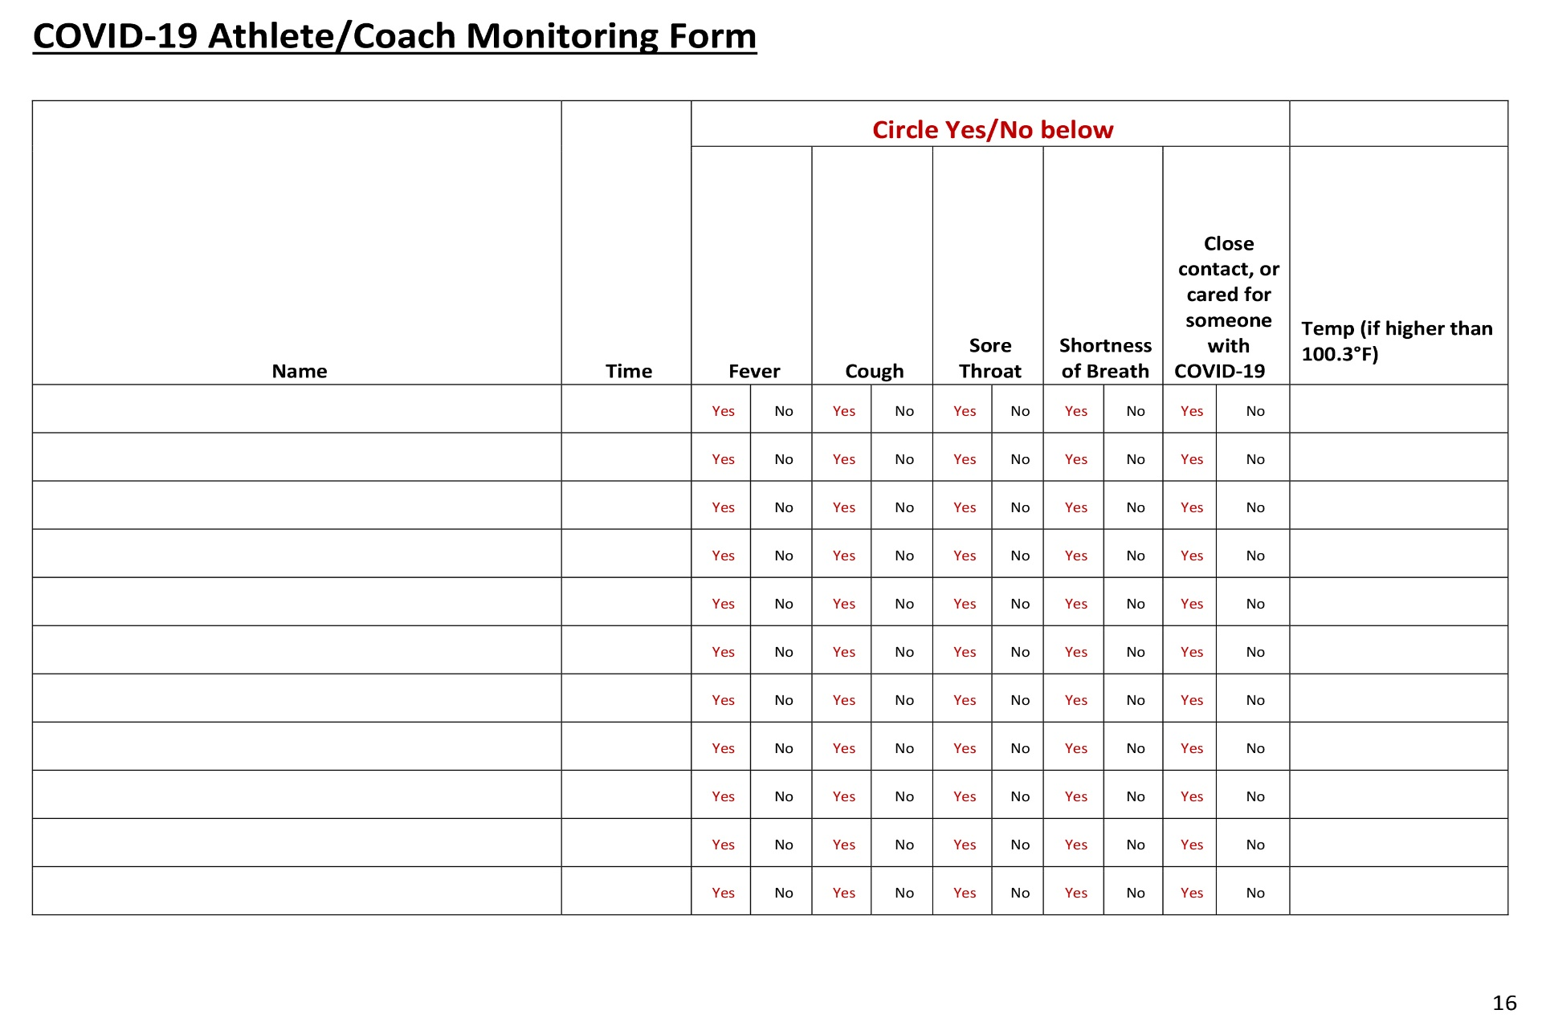
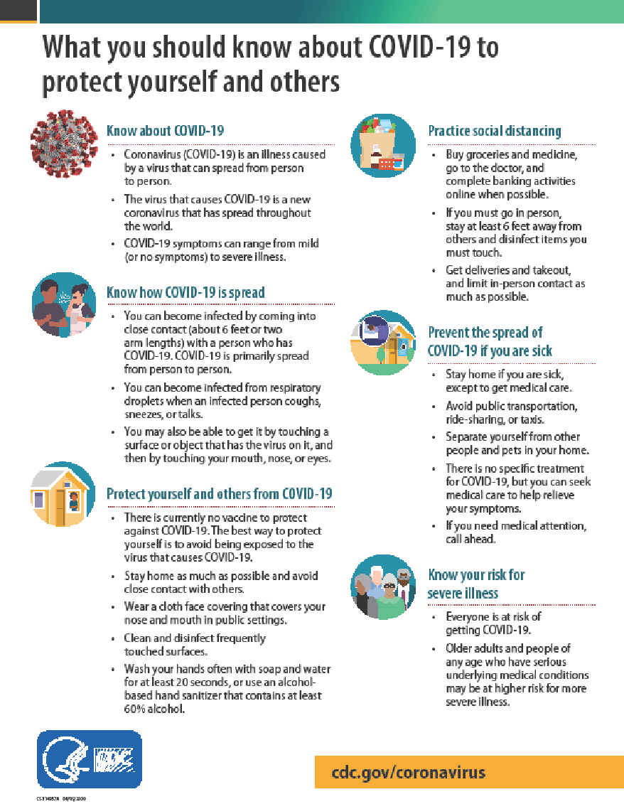

WHAT IS

CONTACT TRACING
?

BACKGROUND
Contact tracing is the process of reaching out to anyone who came into close contact with an individual who is positive for COVID-19. Contact tracing helps monitor close contacts for symptoms and to determine if they need to be tested. Contact tracing is a key strategy for preventing the further spread of infectious diseases such as COVID-19.

WHAT DOES THIS PROCESS LOOK LIKE?
- In contact tracing, public health staff work with a case to help them recall everyone they have had close contact with during the time they were infectious.
- Public health staff then inform individuals who have had close contact (e.g. “close contacts”) that they have potentially been exposed to COVID-19. Close contacts are only told that they may have been exposed to someone who has COVID-19; they are not told who may have exposed them.
- Close contacts are given education, information and support so they understand their risk. They receive information on what they should do to separate themselves from others who have not been exposed, how to monitor themselves for illness, and are made aware that they could possibly spread the infection to others, even if they do not feel sick.
- Close contacts will be asked to quarantine themselves and are encouraged to stay home and maintain social distancing through the end of their infectious period, which is about 14 days, in case they become sick. They should monitor themselves by checking their temperature twice a day and watch for any other symptoms of COVID-19. Public health staff will check in with these contacts to make sure they are self-monitoring and have not developed symptoms.
- If a close contact develops symptoms, they should isolate themselves and let public health staff know. The close contact will be evaluated to see if they need medical care. A test may be necessary unless the individual is already in a household or long-term care facility with a confirmed case, then the close contact would be considered a probable case without a test.

WHAT TERMS SHOULD I KNOW WHEN IT COMES TO CONTACT TRACING?
- A case is a patient who has been diagnosed with COVID-19. A case should isolate themselves, meaning they should stay away from other people who are not sick to avoid spreading the illness.
- A close contact is an individual who had close contact with a case while the case was infectious. A close contact should quarantine themselves, meaning they should stay at home to limit community exposure and self-monitor for symptoms.
- A contact of a close contact is an individual who had or continues to have contact with a close contact. A contact of a close contact should take all regular preventative actions, like washing hands, covering coughs and sneezes, and cleaning surfaces frequently. A contact of a close contact should be alert for symptoms.

RESOURCES FOR MORE INFORMATION
For more information on wearing or making a mask,
visit: https://www.health.pa.gov/topics/disease/coronavirus/Pages/Stop-the-Spread.aspx

For more information on COVID-19, visit the Department of Health’s website, www.health.pa.gov.
Help is available. Contact the Crisis Text Line by texting PA to 741-741
Date Created: 4/30/2020

RESOURCES:

- NFHS: Guidance for Opening Up High School Athletics and Activities
(per update on May 2020)

- Centers for Disease Control – “What You Should Know About COVID-19 to Protect Yourself and Others”

- Centers for Disease Control – “Schools Decision Tree”

- PA Department of Health –“Coronavirus Symptoms”

- PA Department of Health – “What is Contact Tracing”

- PA Department of Health – “Phased Re-opening Plan by Governor Wolf”

- A Guide to Re-Entry to Athletics in Texas Secondary Schools
By Jamie Woodall, MPH, LAT, ATC, CPH and Josh Woodall Med, LAT, ATC

